Intresseanmälan

Skickas till:
Nina Backlund
Personalkooperativet Lilla Mullvaden
Ängomsvägen 8B
862 41 Njurunda

E-post: info@lillamullvaden.nu

Uppgifter barn:

Namn Födelsedatum

1._____________________________ _______________________________

2._____________________________ _______________________________

3._____________________________ _______________________________

Plats önskas fr o m:_______________________________________________

Uppgifter föräldrar:

Namn: __________________________________________________________

Adress: _________________________________________________________

_________________________________________________________

_________________________________________________________

E-post: _________________________________________________________

Telefon: _________________________________________________________

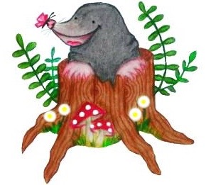
Övrig information:

